# Mechanism of orientation selectivity in the tree shrew primary visual cortex

## Summary

## Introduction

The tree shrew is a highly visual mammal that is closely related to primates. While in the cat visual system, sharp orientation selectivity is already present in layer 4 of the primary visual cortex, in macaques and tree shrews, this transformation occurs from layer 4 to layer 2/3. Similarly, where in the cats, LGN neurons are low pass tuned for spatial frequency, layer 4 neurons show band-pass spatial frequency tuning, in the tree shrews this transformation occurs from layer 4 to layer 2/3 in V1. In this chapter, we examined if the orientation selectivity of the tree shrew layer 2/3 neurons arise from a similar mechanism as has been described in cats and macaques. As the sharpening of feature selectivity occurs entirely within V1, experimenting in tree shrews gives us the opportunity to examine the mechanism through which receptive field properties are generated within a single electrode track rather than paired recordings from more than one visual area. This also gives us the added advantage of recording from neurons that are matched for eccentricity, as this is an important caveat while comparing spatial frequency tuning from different visual areas.

In the tree shrew, orientation selectivity in layer 2/3 neurons was initially thought to have originated from excitatory convergence of a number of layer 4 neurons arranged in a row (Mooser et al., 2004) as has been proposed in cats and macaques (Hubel & Wiesel, 1962; 1968). However, when the data was carefully examined, it was found that the elongation of the receptive fields in shrew layer 2/3 was much smaller than would have been expected from a purely feed-forward mechanism. As a result, it was proposed that the prominent horizontal connections present in layer 2/3 further sharpened the orientation selectivity of neurons (Bosking et al., 1997; Chisum et al., 2003; Mooser et al., 2004; Veit et al., 2013). One study that used optogenetics and optical imaging of intrinsic signals however showed that horizontal connections in the layer 2/3 of tree shrew V1 did not have a modulatory effect on the neuronal responses as previously suggested but rather had an additive effect (Huang et al., 2014). Recently, Lee et al. (2016), suggested that the orientation selectivity in the shrew V1 was established by the spatially off on and off inputs as has been proposed in the cats (Soodak …Kremkow et al., 2016). However, Muly and Fitzpatrick (1992) showed that on and off inputs to layer 2/3 cells have significant overlap, preventing extensive segregation of sub-regions in tree shrews. As a result, the mechanism through which orientation tuning comes about in the shrew V1 is as yet unclear.

It is possible that orientation selectivity in the tree shrews can arise from the anisotropic LGN Driven-Recurrent Model (ALD-RM; Vidyasagar et al., 1996; Kuhlmann & Vidyasagar, 2011; see Figure 1). In the cortex, most cortical neurons receive direct excitatory inputs from sub-cortical neurons biased for orientation and di-synaptic input from un-oriented sub-cortical neurons via inhibitory interneurons (Creutzfeldt & Ito, 1968; Ferster & Lindstrom, 1983). The inhibitory input increases the threshold for firing in the cortical neuron and the remaining signal would automatically be tuned for orientation. Orientation selectivity could then be further sharpened by intracortical mechanisms such as recurrent excitation (Ref) and cross-orientation inhibition (ref). The ALD-RM model also explained the spatial frequency tuning of neurons in both the LGN as well as the layer 4 neurons in cats. LGN neurons showed low-pass spatial frequency tuning (Ref) and at these spatial frequencies, they fire well to all orientations (Vidyasagar & Heide, 1984). At higher spatial frequencies however, the neurons show orientation selectivity. Cortical neurons show band-pass spatial frequency tuning and fire only at spatial frequencies where the LGN neurons are tuned to orientation (Ref). The di-synaptic inhibition in cortical neurons will be non-specific to orientation at lower spatial frequencies where the LGN neuron is not tuned to orientation and causes general attenuation at these lower spatial frequencies. At higher spatial frequencies, the signal that remains is sharply tuned to both the orientation and spatial frequency. The receptive fields of the neurons in such a scheme in cat is shown in figure 1b.

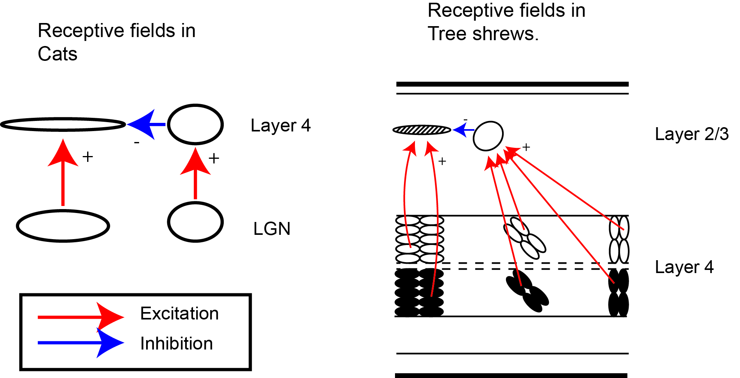

Figure : Mechanism of orientation selectivity proposed in cats and tree shrews. In the cats, layer 4 neurons receive excitatory input from an LGN neuron biased for the same orientation and di-synaptic input via an inhibitory neuron from an LGN neurons unbiased for orientation. The orientation non-specific inhibitory input increases the threshold of firing from the cortical neuron and the resulting signal is tuned for orientation. A similar transformation occurred from layer 4 to layer 2/3 in the tree shrews.

In figure 1b, the excitatory and inhibitory inputs to a layer 2/3 neuron in the tree shrew cortex are shown. Each layer 2/3 neuron in the tree shrew V1 receives converging excitatory inputs from on and off layer 4 neurons (Muly & Fitzpatrick, 1992) and has extensive horizontal connections (Bosking et al., 1997). Layer 4 neurons are also broadly tuned to orientation and show low pass spatial frequency tuning while layer 2/3 neurons show sharp orientation selectivity and show band-pass spatial frequency tuning (Van Hooser et al., 2013). It could be that a similar transformation that occurs from LGN to layer 4 in the cat visual system happens from layer 4 to layer 2/3 in the tree shrews. We tested the following hypothesis to test whether this was indeed the case.

**(H1)** As neurons in the on and off sub-divisions of layer 4 converge onto layer 2/3 neurons directly above them and most layer 4 neurons demonstrate orientation biases, we predicted that most of the layer 4 and layer 2/3 neurons in the same track were tuned to the same orientation.

**(H2)** Orientation tuning of layer 4 neurons are evident at higher spatial frequencies similar to that of cat LGN neurons.

**(H3)** Finally, we predicted that layer 2/3 neurons fire best at spatial frequencies where the layer 4 neuron is best tuned for orientation.

## Methods

#### Surgery and Anaesthesia

Detailed surgical procedures are outlined in the Methods chapter. Briefly, the animal was anaesthetized using a mixture of Ketamine and Xylazine, a venous catheter was inserted in to the femoral vein and a tracheostomy performed to assist in breathing during the experiment. The animal was administered muscle paralysant (Vecuronium Bromide) intravenously and was anaesthetised using Isoflurane (0.5-1%) for the duration of the experiment. Hard contact lenses were fitted to the eye to prevent corneal drying. In some tree shrews, additional lenses were used to correct for any refractive errors. A craniotomy and durotomy were performed over the location of V1 (Horsley-Clarke Co-ordinates A2.5 to P2.5). ECG and frontal EEG were monitored during the experiment. At the end of the experiment, the animal was euthanized using an overdose of pentobarbital sodium and perfused using 0.1M Phosphate Buffer (PB) solution followed by 4% Paraformaldehyde in 0.1M PB. The brain was removed and stored in sucrose (20-25%) for histology.

#### Electrophysiology

High impedence, lacquer coated tungsten microelectrodes (FHC Metal Microelectrodes Inc., ME, USA; impedance= 12-18 MΩ) were lowered into the brain at an angle perpendicular to the cortical surface. The signal was amplified and filtered (x 10,000 gain, bandpass filtered between 300-3000 Hz, A-M systems) and fed into an audio speaker as well as an analog to digital converter (Cambridge Electronic Design Limited, Cambridge, UK; digitised at 22.5 kHz). Neurons were recorded from Layers 2/3 and Layer 4. Layer 4 could be identified by a characteristic ‘swish’, first for on stimuli and then for off stimuli, in the tree shrews. Where we no longer heard the swish, we concluded that we exited layer 4 and into layer 5. Neurons in layers 5 and 6 were not recorded from. Lesions (6 μA for 6s) were made at the end of each track. The electrode was withdrawn and lesions were made at regular intervals to trace the path of the electrode through the brain. The data was recorded as a spike trace using the spike 2 software (CED, Cambridge, UK). The spikes were templated and the spike timing exported as a text file. Further analysis was performed using custom MATLAB® code (The Mathworks Inc, USA).

#### Stimulus Presentation

A hand-held projectoscope was used to mark the receptive field boundaries. Using this, the centre of the monitor was aligned with centre of the receptive field prior to stimulus presentation. Stimuli were presented using a BARCO monitor (Frame Refresh Rate= 80 Hz; Reference Calibrator Plus; Barco Video and Communications, Belgium) and generated using Visage (VSG, Cambridge Research Systems, Cambridge, UK) and custom Stimulus Description Language (SDL) scripts. While recording, the monitor was placed at a distance of 114 cm from the eye. For each of the different stimuli described below, ten complete stimulus sets were completed.

##### Bar Stimuli

For each neuron, an initial estimate of optimum orientation was obtained using bars moving bi-directionally across the screen. The background was a uniform gray screen. Depending on the polarity of the neurons, either a light bar or a dark bar was used (contrast= 100 %). The bar was usually 8o long (ranging between 4 and 8 degrees) and 0.5o wide (ranging between 0.1 and 1o). A total of 18 different orientations were tested and PSTHs (see chapter 2) were made online using the Spike 2 software. The orientation that yielded the highest firing rate was used for further testing.

##### Grating Stimuli

For all neurons, once optimum orientation was determined, spatial frequency tuning was studied. Drifting sine-wave gratings (TF= 4Hz, Contrast=100%) of increasing spatial frequencies (between 0 and 2.2 cpd) and in the optimum orientation were presented to neurons. For layer 4 neurons, the spatial frequency response to gratings of the non-optimum was also recorded. The responses were recorded and stored for further analysis.

#### Data Analysis

##### Orientation Selectivity of bars

The orientation selectivity of all the cortical neurons we encountered were measured using thin bars. The circular mean and circular variance of this response was calculated using the following formulas to measure the optimum orientation and sharpness of the tuning.

$$CV=1-|\frac{mean(r*e^{(i*2θ)})}{mean(r)}|$$

where $θ$ is the orientation of the bar and r is the response of the bar to each orientation.

$$CM=atan(\frac{1}{n}.\sum_{j=1}^{n}{r}*sinθ,\frac{1}{n}.\sum_{j=1}^{n}{r}*cosθ)$$

One of the key predictions of our model was that the optimum orientation of the neuronal responses did not vary along a penetration perpendicular to the cortical surface. In order to test this hypothesis, we calculated the absolute difference in preferred orientation between the first neurons we encountered in layer 2/3 in each track and all the neurons that were present in the same track.

It is possible that in our penetrations, the electrode angles were not always exactly perpendicular to the cortical surface. In order to make sure that any differences we observed in the optimum orientation were not due to the angle of the track, we also undertook a simulation experiment. We obtained an orientation tuning map of the tree shrew V1 (Bosking et al., 1997) and converted the RGB map into HSV co-ordinates. We then converted the hue values into angles and used this map for further analysis. A point was placed on the orientation map and the orientation of a thousand pixels randomly placed at a particular distance were subtracted from the orientation of the original pixel. This procedure was repeated a 1000 times and for 6 distances (50, 100, 150, 200, 250, 300 mm). A probability histogram was calculated to determine the probability of obtaining various absolute differences.

##### Spatial Frequency Tuning

For each layer 2/3 and layer 4 neuron, the spatial frequency tuning curve was obtained from the response of the neuron to drifting gratings of the optimum orientation and increasing spatial frequencies. The SDFs (see Chapter 3: Methods) of the neuron were analysed using Fourier Analysis (using the fast fourier transform algorithm (FFT) in MATLAB ®) and a modified version of the F1/F0 ration called the modulation index (as described by Van Hooser et al.,2013) was calculated using the following formula.

$$Modulation Index(MI)=2*\frac{F_{1}}{F_{1}+F_{0}}$$

If the MI was greater than 1, the neuron was classified as simple and the F1 component was used as the response and if the MI was lesser than 1, the neuron was classified as complex and the DC component was used as response. This version of the formula was used so that we could compare our data to previously published data from the tree shrews. The upper and lower cutoff frequencies were calculated as the frequencies above and below the optimum spatial frequency where the response first dropped below half the maximum response respectively. The bandwidth of the neurons in octaves was calculated as follows.

$$b_{oct}=log2(\frac{uppercutoff}{lowercutoff})$$

##### Orientation Tuning using Gratings

For layer 4 neurons, the spatial frequency tuning of the neuron at the optimum and the orthogonal orientations was also recorded. In our second hypothesis (H2), we predicted that the orientation selectivity of layer 4 neurons would sharpen as the spatial frequency increased. We calculated the orientation selectivity index (OSI) to determine the orientation of the neurons at each spatial frequency as follows.

$$OSI=1-\frac{R_{orthogonal}}{R_{optimum}}$$

where Rorthogonal is the response at the orthogonal orientation and Roptimum is the response at the optimum orientation at each spatial frequency. Higher values of OSI mean that the neuron showed sharper orientation tuning. The spatial frequency at which the neuron showed maximum orientation selectivity was obtained.

#### Histology and Track Reconstruction

At the end of each track an electrolytic lesion (6 $μ$ a for 6s) was made. After the experiment was completed, the brain was removed following perfusion using 0.1M Phosphate Buffer and 4% Paraformaldehyde and was stained for Nissl substance using Cresyl Violet Acetate (ph=3.4-3.6). The tracks were later reconstructed and the laminar position of each neuron was determined.

## Results

#### Laminar Position of neurons

We recorded from 75 neurons from the V1 of 13 tree shrews (M=6; F=7). The laminar position of all units were determined using track reconstructions based on lesions made during recording (yellow arrows in fig 1a). In the tree shrew, the V1 shows prominent striation corresponding to layer 4. Layer 3c is a cell sparse region just above layer 4. Neurons recorded above layer 3c were classified as belonging to layer 2/3. We recorded from 30 layer 2/3 neurons; 29 layer 4 neurons and 16 layer 3c neurons.

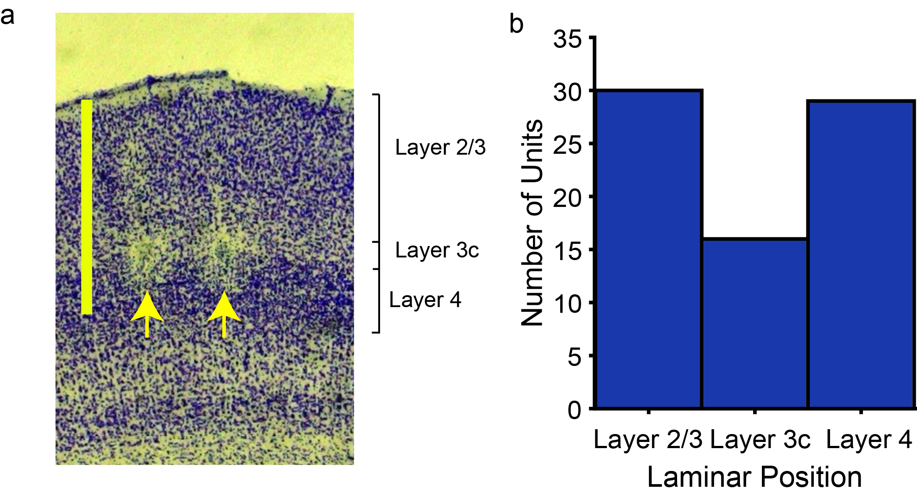

Figure 1: The distribution of laminar positions from which we recorded. a) A photomicrograph of the tree shrew primary visual cortex with layers 2/3, 3c and 4 marked. The two arrows point to two lesions made in layer 3c of two separate tracks. The scale bar is 1 mm. b) Histogram showing the number of neurons recorded from each of the layers.

#### Distribution of the circular variance

The distribution of circular variances for neurons in the three layers, calculated from their responses to thin moving bars are shown in fig 2. The median CV of layer 2/3 neurons was 0.59 (n=28; 95% CI= [0.32, 0.68]); that of layer 3c was 0.87 (n= 16; 95% CI= [0.68, 0.91]) and that of layer 4 neurons was 0.88 (n=29; 95% CI=[0.84, 0.90 ]). The three distributions were significantly different from each other (p $<$ 0.001, Kruskal-Wallis test). Post-hoc tests revealed that there was a statistically significant distribution between the distribution of CVs of neurons in layer 2/3 and layer 3c (Wilcoxon rank sum test, z=2.37; p $<$ 0.01) and between layer 2/3 and layer 4 (Wilcoxon rank sum test test, z= 3.58, p $<$ 0.001). The difference between the distributions of CV of layer 3c neurons and layer 4 neurons was not statistically significant (Wilcoxon rank sum test, z= 0.67; p=0.25).

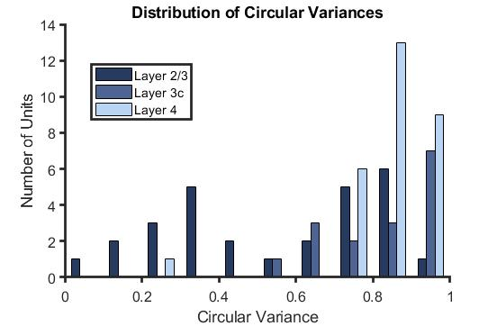

Figure 2: The distribution of circular variance of neurons of the shrew V1.

#### Circular mean of neurons within a track

In **[H1]**, we predicted that the layer 2/3 and layer 4 neurons in each track will have the same orientation. In this section, we aimed to test this hypothesis. To test this hypothesis, we took the absolute difference between the circular means of each layer 2/3 neuron and all the layer 4 neurons from that track. Since layer 3c neurons showed a similar degree of orientation selectivity as the layer 4 neurons and it has been shown that layer 3c also receive direct inputs from the LGN (Reference), we also took the absolute difference of the layer 3c neuron’s orientation from the corresponding layer 2/3 neuron. The results from 37 pairs of neurons from 18 tracks are presented in fig 3. We found that there were two peaks, one with the centre at 0o and the other at 65o. The distribution of absolute differences was significantly different from a uniform distribution (chi-square test; n=37; df=5; chi-square=12.35; p<0.005).

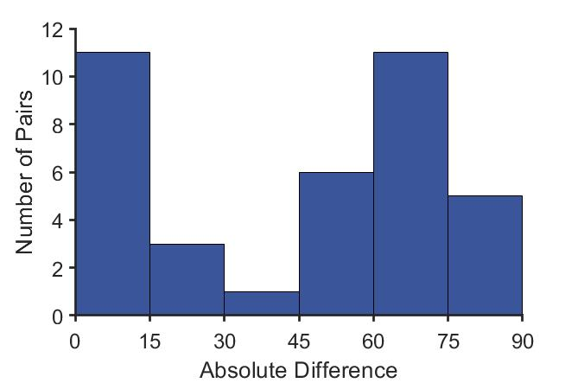

Figure 3: The absolute difference between the circular mean of the first layer 2/3 neurons in each track and subsequent neurons from layer 3c and layer 4 in each track.

We then split the distribution into two groups: pairs of neurons that were tuned to orientations less than 45o (Group 1) apart and pairs tuned to orientation greater than 45o apart (Group 2). We then determined if the absolute difference was between the layer 2/3 neuron and layer 3c neurons or between layer 2/3 neuron and layer 4 neurons. These results are shown in fig.4. We found that in Group 1, the majority of the difference pairs were between layer 2/3 and layer 4 neurons (N=15; Binomial Distribution, p=0.04). In Group 2, majority of the difference pairs were between layer 2/3 and layer 3c neurons (N=22; Binomial Distribution, p=0.04)

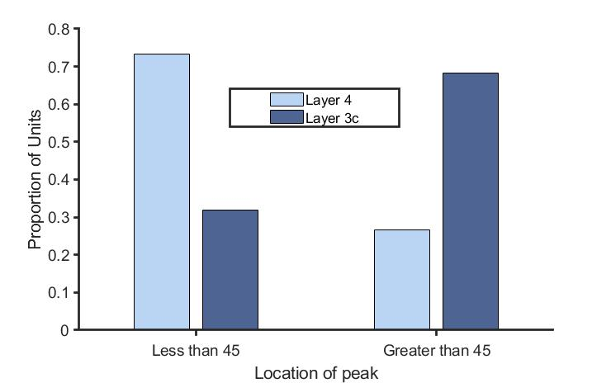

Figure 4: The proportion of neurons from layers 3c and layer 4 with absolute differences greater and lesser than 45o.

In order to ensure that the second peak we observed in fig. 4 wasn’t due to track angles, we undertook a simulation experiment (See methods section). We found that for the shortest distance between the layer 2/3 and layer 4 neurons in our sample (50 mm), there was a high probability of getting an absolute difference of 0 but this probability decreased steadily. For the greatest horizontal distance between two neurons in our sample (300 mm), the probability of obtaining the same orientation was lower. While there was a general trend towards getting neurons that were tuned closer to 90o apart, there was no specific bias for a difference of 65o. The highest probability of obtaining a peak at 65o was when the horizontal distance was 250 mm (p=0.045).

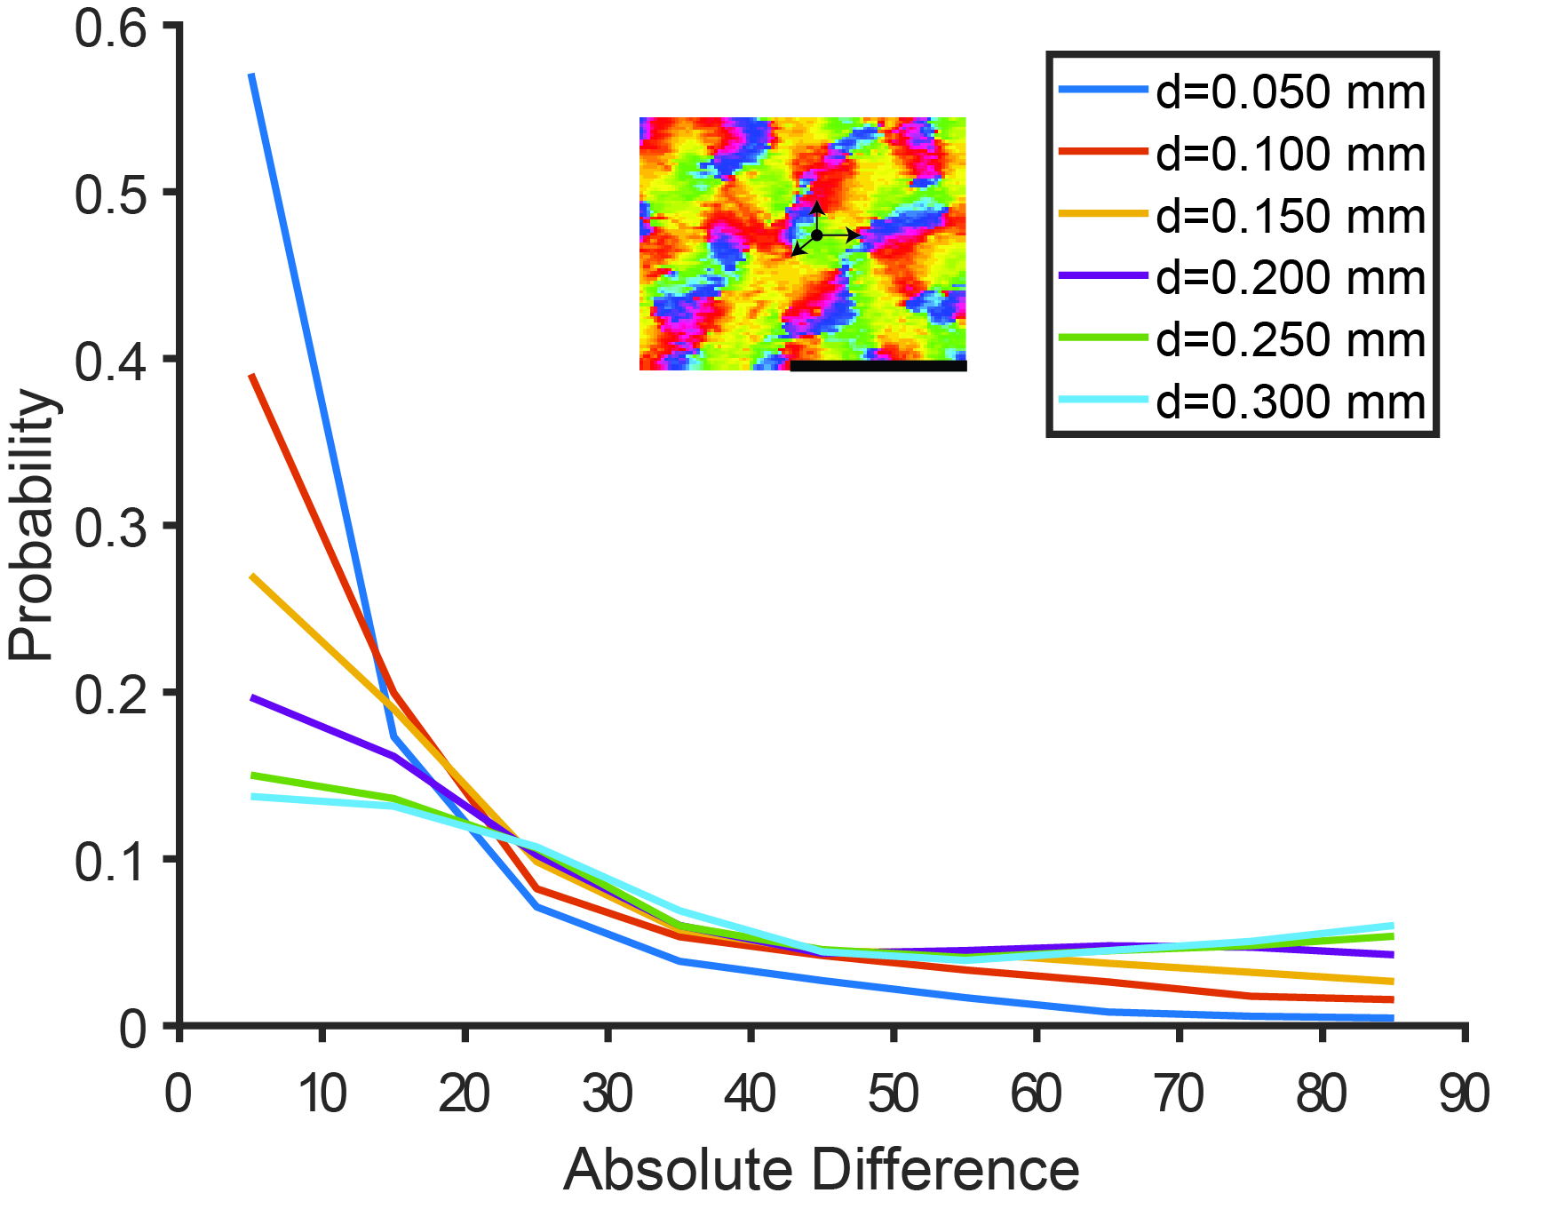

Figure 5: Results of a simulation experiment: The orientation tuning map (inset) was taken from Bosking et al., 1997. On this map, points were randomly placed and the orientation of 1000 pixels randomly selected at one of the distances in the legend was subtracted from the original data point. For each distance, the distribution of absolute differences for the 1000 pixels are shown by the lines in the graph. Black line is 1mm.

#### Spatial Frequency Tuning of neurons

The distribution of the low cut-off, preferred and high cut-off spatial frequencies of the neurons in layer 2/3 and layer 4 are shown in fig. 6. Results from only these two layers are shown as we propose that the orientation selectivity of layer 2/3 neurons arise predominantly from layer 4 neurons. We found no significant differences between the spatial frequency tuning between the two layers (n23=27; n4=27; optimum spatial frequency: Wilcoxon rank sum, z=-0.29, p=0.76; low cut-off: Wilcoxon rank sum, z=-0.75; p=0.45; high cut-off: Wilcoxon rank sum, z=-1.69, p=0.09). although layer 2/3 neurons tended to show high spatial frequency attenuation when compared to layer 4 neurons. When the bandwidth of spatial frequency tuning in octaves was calculated, we found that the layer 2/3 neurons showed slightly sharper tuning (median layer 2/3 boct= 2.2; n=16; median layer 4 boct=2.3; n=9). 11 of the 27 layer 2/3 neurons and 18 of the 27 layer 4 neurons were low-pass tuned to spatial frequency.

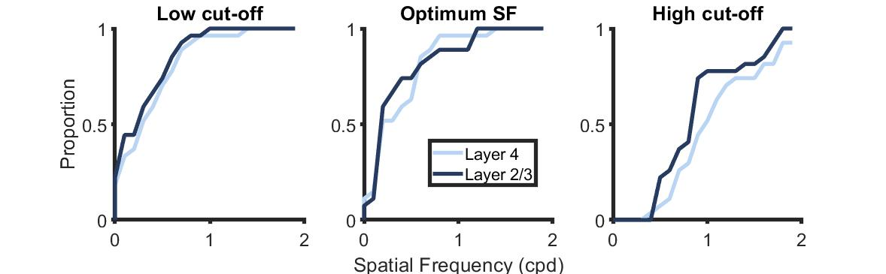

Figure 6: The cumulative distribution of the spatial frequency tuning of neurons in layers 2/3, 3c and 4 of the Shrew V1.

In **[H2]**, we predicted that the layer 4 neurons will be more tuned to orientation at higher spatial frequencies. We tested this hypothesis by comparing the optimum spatial frequency tuning of layer 4 neurons with the spatial frequency where they demonstrated most orientation tuning in 20 neurons. These results are presented in fig. 7. Most neurons are located above the identity line, indicating that the spatial frequency where they are maximally tuned for orietnation is greater than the optimum spatial frequency of the neuron. The median optimum spatial frequency of the layer 4 neurons was 0.35 cpd (95% CI= [0.2, 0.6]). The median of the spatial frequency where the orientation selectivity index was the highest was 0.8 cpd (95% CI= [0.6, 1.2]). The spatial frequency at which the layer 4 neurons were most tuned for orientation was significantly higher than the neurons’ optimum spatial frequency (Wilcoxon rank sum test, n=20, z= -2.93, p $<$ 0.005).

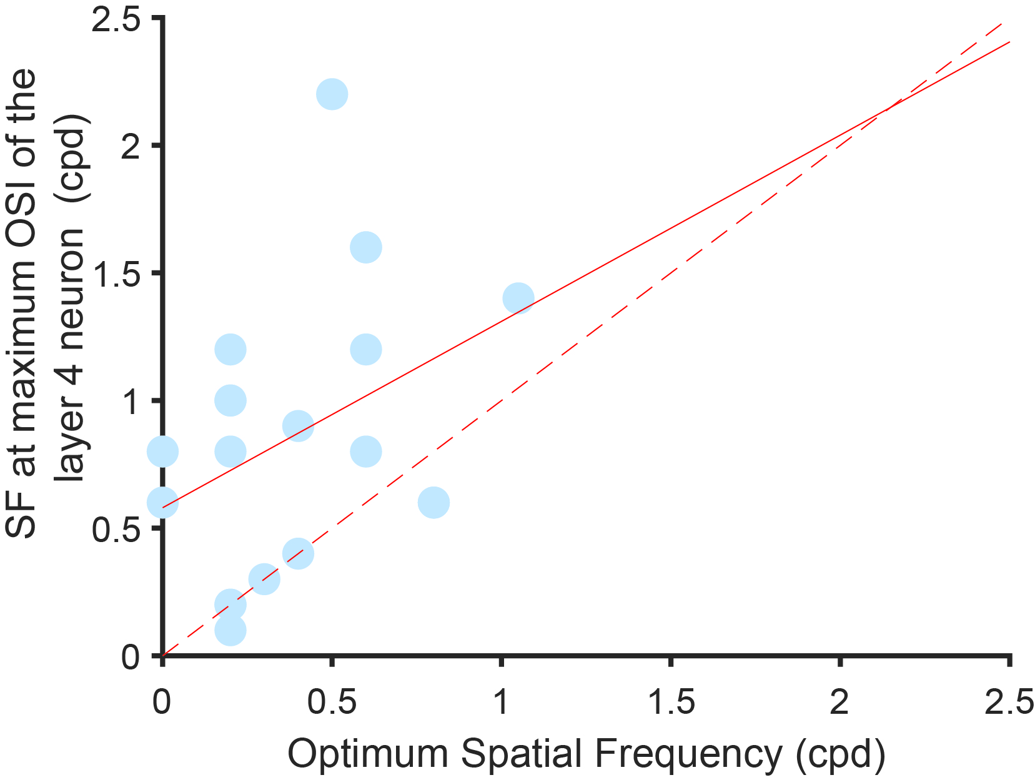

Figure 7: The relationship between the optimum spatial frequency of the layer 4 neurons and the spatial frequency at which the layer 4 showed the highest OSI. The dashed line is the identity line. The solid red line is the result of a linear fit of the form y=mx+c to the data (m= 0.73 [-0.15, 1.61] and c=0.58 [0.15, 1.01]).

The results from 18 tracks where we compared the peak spatial frequency of the layer 2/3 neurons and the spatial frequency where the layer 4 neurons were tuned for orientation are shown in fig.8. Fig 8a shows the spatial frequency tuning curve of a layer 2/3 neuron and that of the corresponding layer 4 neuron to the optimum and orthogonal orientation. We hypothesised **[H3]** that the optimum spatial frequency of the layer 2/3 neuron and the spatial frequency at which the layer 4 neurons was most tuned for orientation would be similar. We found that this relation held true only in 3 of our 18 tracks. The median of the optimum spatial frequencies of the layer 2/3 neurons was 0.2 cpd (95% CI= [0.1, 0.4]). In this sample of layer 4 neurons, the spatial frequency where the neurons were most tuned to orientation was 0.8 cpd (95% CI= [0.3, 1.2]). In most of the tracks the maximum OSI of the layer 4 neurons occured at higher spatial frequencies when compared to the optimum spatial frequency of the layer 2/3 neuron (Wilcoxon signed rank test, n=18, p $<$ 0.005) as demonstrated by the data points skewed closer to the y-axis.

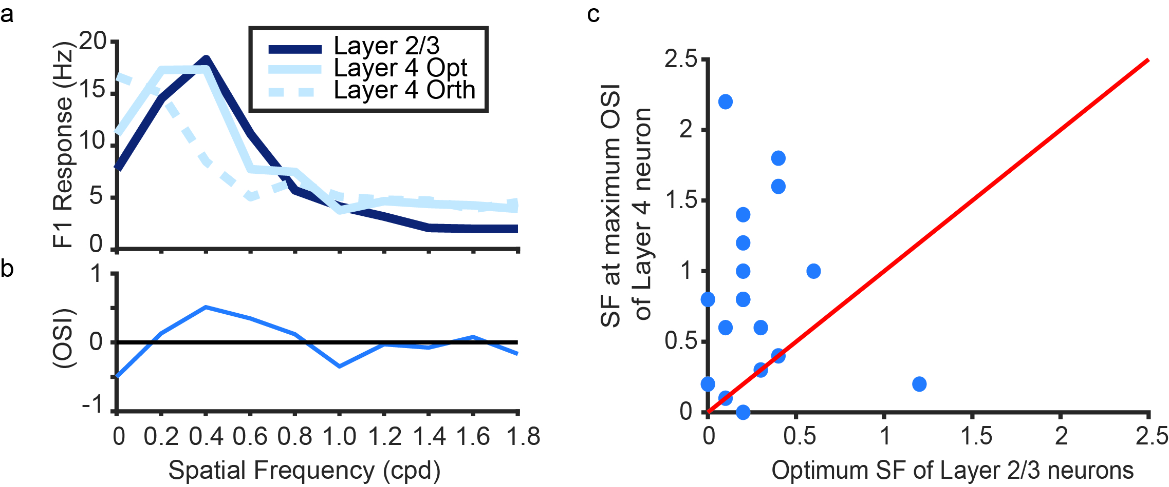

Figure 8: The cumulative distribution of the spatial frequency tuning of neurons in layers 2/3, 3c and 4 of the Shrew V1.

## Discussion

In this chapter, we used extracellular recordings from layers 2/3 and layer 4 of the tree shrew V1 to examine if orientation selectivity could arise from sharpening the biased inputs from layer 4 neurons via the ALD-RM model. As hypothesized, we found that the layer 4 neurons and the layer 2/3 neurons were tuned to similar orientations **(H1)** and that as the spatial frequency of the stimulus increased, the orientation tuning of the layer 4 neurons got sharper **(H2).** In **(H3)**, we hypothesised that the layer 2/3 neuron’s peak spatial frequency would be similar to the spatial frequency where the layer 4 neurons showed maximum orientation tuning. We found that this was only true in three neuron pairs. These results are further discussed below.

##### Sharpening of orientation tuning in layer 2/3 and layer 4

In this chapter, we determined the orientation selectivity of V1 neurons from Layers 2/3, 3c and 4. We found that most neurons in layer 4 and layer 3c were broadly tuned to orientation. While layer 2/3 neurons showed sharper tuning to orientation overall, individual neurons showed a bimodal distribution of orientation selectivity. These results are consistent with previous results published in the tree shrews (Van Hooser et al., 2013) and those published in the primary visual cortex of macaques and cats where a wide range of orientation selectivities was reported in V1 (Ringach et al., 2002).

In our study we used oriented bars to measure the degree of orientation selectivity of neurons. Bars stimuli have a complex spatial frequency spectrum and yield higher values of orientation selectivity when compared to gratings of the optimum spatial frequencies (Reference). As neurons showed better orientation selectivity to bars, it was easier for us to determine the optimum orientation for further testing when bar stimuli were used. However, it is likely that we have over-estimated the extent of orientation selectivity, especially in layers 3c and 4 of shrew V1. Van Hooser and colleagues also showed that there were two groups of layer 4 neurons, those towards the edges of the layer 4 that showed sharp orientation tuning and those in the middle that showed broader orientation selectivity. In our sample (29 neurons), we only found one layer 4 neuron that showed sharp orientation tuning, however, this does not exclude the presence of more sharply tuned units at the edges of layer 4.

##### Orientation columns in the tree shrew V1.

In **H1**, we hypothesised that if the excitatory input from layer 4 neuron informed the orientation selectivity of the layer 2/3 neuron, then both neurons will have the same optimum orientation. We found that this was indeed the case. This also indicates that within an electrode track, the columnar architecture observed in layer 2/3 might already be present in layer 4. Surprisingly however, we found that layer 3c neurons in V1 were tuned to an orientation 65o away from the optimum orientations of the layer 2/3 and the layer 4 neurons, indicating that there is a laminar segregation in the optimum orientation of neurons in the tree shrew V1. Neurons in this layer also show broader orientation tuning unlike other layer 2 or 3 neurons. Here we examine two possibilities for the difference in receptive field properties of layer 3c neurons.

###### Layer 3c is an input layer and is an extension of layer 4.

The bottom of layer 3c neurons get inputs from layer 6 neurons in the LGN in tree shrews. As a result, it has been suggested that this layer might be an extension of layer 4, the LGN input layer in tree shrews (Conley et al., 1984). Our results where the orientation biases of layer 3c neurons are similar to that of layer 4 neurons also supports this hypothesis (also see Van Hooser et al., 2013). Further, it has also been shown that while there are extensive horizontal connections within layers 2-3b, layer 3c lacks horizontal connections, similar to layer 4.

###### Layer 3c forms part of the koniocellular pathway in tree shrews.

In macaques, layer 3B, which is located just above layer 4, contains neurons that are broadly tuned to orientation. This layer receives direct koniocellular inputs (from W-like cells) and shows blobs when stained with cytochrome oxidase. As layer 3c cells receive inputs from W-like cells, it has been suggested that layer 3c parallels layer 3b in the tree shrew cortex. It is however important to note that it was layer 3b neurons and not layer 3c neurons in the tree shrew cortex that showed patchy cytochrome oxidase staining. As a result, the pathway from W-like cells in the retina via layer 3 of the LGN to layer 3B of V1 could be the equivalent of the koniocellular pathway in macaques.

Layer 3c provides cross orientation inhibition to layer 2/3 neurons.

Another possibility could be that the neurons in layer 3c could be providing inhibitory inputs to the layer 2/3 neurons. As we have shown in this study, the layer 3c neurons show broader orientation selectivity when compared to the rest of the layer 2/3 neurons and are tuned to an orientation 65o away from the orientation of the corresponding layer 2/3 and layer 4 neurons. Layer 3c neurons are also meant to receive inputs from the layer 4 (Fitzpatrick, 1996). Layer 3c neurons could pool responses from the layer 4 neurons and provide the basis for cross orientation inhibition in the layer 2/3 neurons rather than both excitatory and inhibitory inputs arising from layer 4. If the excitatory and inhibitory inputs from layer 4 and layer 3c neurons serve to establish the initial orientation selectivity, then horizontal connections in layer 2/3 could amplify the orientation response of the neurons through recurrent excitation. This would also explain the results of experiments where the stimulation of horizontal connections had an additive effect rather than the modulatory effect previously attributed to them (Huang et al., 2014).

##### Distribution of Spatial Frequency

We also observed that spatial frequency tuning sharpened from layer 4 to layer 2/3, however this sharpening was not statistically significant (2.2 octaves to 2.3 octaves from layer 4 to layer 2/3). However, bandwidth calculation could only be made in neurons that showed band pass spatial frequency tuning. There was a significant change in the number of layer 4 neurons that were low pass tuned to spatial frequency (67%) when compared to the layer 2/3 neurons (41%). Of the bandpass tuned neurons, layer 2/3 neurons also showed higher spatial frequency attenuation. These results indicate that there was sharpening of orientation selectivity from layer 4 to layer 2/3 in the tree shrew V1.

It is also important to note that when the low pass, optimum and high pass spatial frequencies of neurons were compared, there was no statistically significant differences between the three layers, suggesting that the distribution of spatial frequency tuning stayed similar throughout the primary visual cortex. Taken together with the sharpening of spatial frequency tuning from layer 4 to layer 2/3 neurons, these results indicate that in most layer 2/3 neurons, there is a direct sharpening of the inputs and the extensive low spatial frequency attenuation reported in cats (Ref.) happens to a lesser extent in tree shrews.

##### Spatial Frequency Dependence of Orientation Tuning

We examined if the orientation selectivity of layer 4 neurons varied in relation to the spatial frequency tuning of the neurons. We found that in most cases, layer 4 neurons showed sharper orientation selectivity at higher spatial frequencies as predicted in **(H2)**. In the tree shrews then, orientation tuning of the layer 2/3 could be explained if these neurons responded best at spatial frequencies where the layer 4 neurons were showed sharper orientation selectivity as suggested in **(H3)**. However, when we tested **(H3)**, we found that it was true only for a small proportion of neurons. In only 5 pairs of neurons (out of 18) did the layer 2/3 neuron respond best at or above the spatial frequency where the layer 4 neuron was best tuned to orientation. In the other pairs, the layer 4 neurons were optimally tuned for orientation at spatial frequencies higher than the optimum spatial frequency of layer 2/3 neurons. What does it mean…

In **(H3)** we hypothesised that the peak spatial frequency of the layer 2/3 neurons would be similar to the spatial frequency where the orientation tuning of the layer 4 neuron was greatest. We only found this result in a small proportion of the neurons in our study. As a result, while we cannot definitely conclude that neurons in layer 2/3 use non-specific inhibition to sharpen the orientation biases inherited from the layer 4 neurons, we do have some evidence that suggests that this could be the mechanism through which orientation arises in some neurons in the tree shrew V1.